High Speed 2 (HS2)- A planned transport project
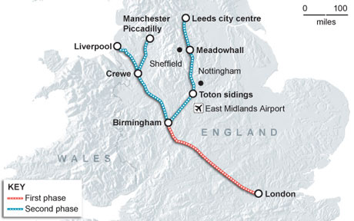
Background Information
HS2 is a new/ proposed high speed railway that will link London to Birmingham. It will start running in 2026 and then a second phase (HS3), will be built, which will branch in to Yorkshire and North-West England. The building of HS2 is quite controversial and there are many people that are opposed to it being built. HS1 is the Euro Tunnel that joins the UK to mainland Europe.

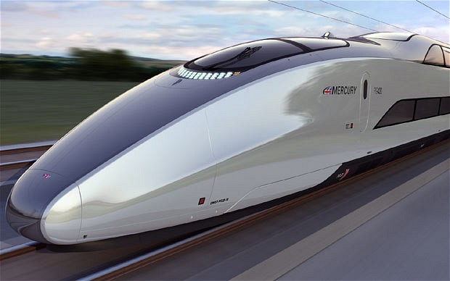

Benefits economic/ environmental
- Connects major UK cities E.g. London, Birmingham, Manchester, Edinburgh
- Much quicker journey times (London- Birmingham current- 1h2 24mins, HS2 time- 49 mins)
- Cheaper than air travel and will emit far less carbon emissions, so will reduce the number of people flying
- When the railway is built more trees will be planted which will mean that HS2 is meant to ne carbon neutral
- Will generate income and provide economic benefits for the country as commuting is easier so companies can move further out of the South-East
- Thousands of jobs will be created which will boost the economy and reduce unemployment

Disadvantages- economic/ environmental
- Some houses along the route will lose value
- Approx 400 houses are scheduled for demolition
- The railway line goes through an Area of Outstanding Natural Beauty (AONB) in the Chilterns
- 33 ancient woodlands will be reduced in size
- In Birmingham a nature reserve will be split in two by the railway
- Noise pollution and pollution is produced
- The route will cross the Mid-Colne Valley, which is a Site of Special Scientific Interest (SSSI), famous for its birds

