Queen Elizabeth Olympic Park- A case study of a planned or completed housing/ facilities [roject developed in an environmentally sensitive way
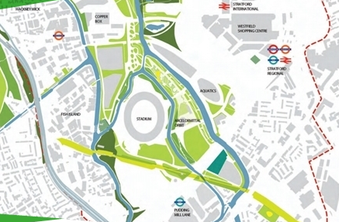
v
What have they done to improve the area
- The area was a Brownfield site that was abandoned and left derelict. It was a dumping ground and had a bad reputation.
- Dirty water ways like the River Lea have been cleaned up, rubbish and litter has been cleaned and new vegetation introduced to the area. 6.5km of waterways were cleaned up
- 35km of new footpaths for cycles and pedestrians were introduced for people to encourage walking and cycling and make it more appealing for them
- 30 new bridges were built to connect the park with East London to improve transport and make it easy for people
- New habitats were created for wildlife. Grasslands, ponds and woodlands were planted to make the area more eco friendly and make the surroundings more pleasant.
- Thousands of job were created during the construction (4000) and long term jobs were created in the new facilities which will boost the local economy.
- Local people have better transport in the area now as the Jubilee line was extended, the bus links were improved, the train stations were improved and the bus links were improved. Cycling is encouraged and there are ‘Borris Bike’ stands everywhere. 195 trains per hour!
- Flats are considered ‘affordable’ and they are not allowed to be owned, so the rich do not just purchase lots of flats and charge high rents. For them not them not to be lived in.
- Cheap facilities encourage people to get fit
How is the development sustainable?
- 98% of the demolished buildings were used in the redevelopment, E.g the Olympic stadium is made using old gas pipes
- The stadium used ‘no-flush’ toilets which conserve water
- 183 000 tonnes of carbon is saved heating homes due to good insulation in the homes
- Using LED light bulbs which use less electricity mean 5000 tonnes of carbon is saved each year
- Living green roofs have been planted on tall buildings to absorb carbon dioxide and encourage wildlife
- Allotments are located in the centre of residential blocks to encourage people to grown their on fruit and veg, and encourage wildlife
- Biomass power station uses more renewable supply of energy to heat home and water in the East Village and stadiums.
- Buildings are encouraged to use more natural light to avoid turning on lights. And therefore saving energy
- East village has a water recycling project which takes water from roofs and gutters and uses the water for gardens. ‘Grey water’ from showers and washing machines is used to flush toilets to reduce the amount of water being used
- There is no/ little parking in the area to reduce congestion and encourage public transport use which pollutes less than private cars.

